SUPERKARTCLUBWA INC
Home of Long Track Racing in WA
Wanneroo Raceway
Sunday 30 JULY 2023
With MX5 Racing

Event | Karts with MX5 @ Wanneroo Raceway, Wattle Ave W, Neerabup,
Date | 30th July 2023
Permit number | Racers signed…………………………………..

Track Details | 2.415 km with racing clockwise (full circuit )  track density max 40 karts
Pit and Ramp Details | Pits for this event are at the south ramp | Track entry for racing will be via sth ramp

 |  | Classes |  | see below some popular grouping.
 |  | Senior Classes |  | Gearbox  WA Open Performance  Non Gearbox |  | - 125 cc light & heavy  - 250 cc Inter and 250cc National  - Up to 250 cc  - Tag125 (light & heavy & super heavy)
 | Race Format |  | Practice |  | 2 x 5 minute sessions
 |  |  | Heats |  | 5 heats of 8 minutes --- transponders are required
 |  |  | Gridding |  | Random grids
 |  |  | Points |  | 401 , all points count to final result

 | Timetable |  | 6.30 am  7.00 am  8.15 am  8.35 am  8.45am  9.15 am  various  3.00 | Gates Open  Race Office Open (for driver and officials Registration )  Officials Sign In and Briefing and Track inspection  Drivers Registration Desk Closes  Drivers Briefing Compulsory Attendance  First Kart Practice Session  Race events  Track closed
SUPERKARTCLUBWA INC
Home of Long Track Racing In WA
Sunday 30 JULY 2023

Competitor  Information |  | - Driving of karts to the grid and from the track is permitted, in the direction of traffic flow (road) markings (clockwise) AND a slow constant speed.  - Kart retrieval will be performed by designated vehicles  - Transponders will be required for scoring and laptimes  - Drive on Scales will be in operation.  - Weights – as per SKCWA guidelines  - Tyres – as per SKCWA guidelines  - Kart Bays are included in entry fee (2 karts per car bay )  - Paddock and venue details (refer web for diagram)  - Canteen will be open for breakfast and lunch.
Event Program | The organizers reserve the right to add to or amend these guidelines , including at the drivers briefing prior to the start of the event. These guidelines will stand unless any variance is specifically stated at the drivers brief.

Specific Venue Requirements | - No vehicles under carports  - No dogs or animals are allowed anywhere within the facility  - No dumping of Fuel or Tyres, please make own arrangements  - Marquees and pop up shelters are not to be erected in the pits without consent of the Club or venue owners, contact organizers for assist.  - No unlicenced driving of vehicles within the facility

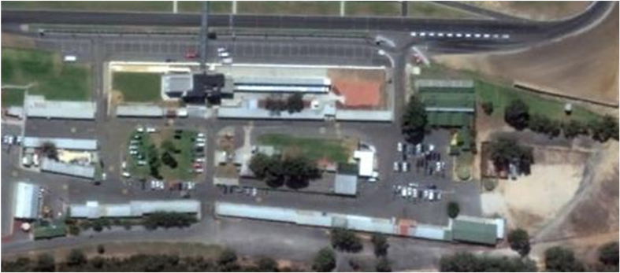

SUPERKARTCLUBWA INC
Home of Long Track Racing In WA
Sunday 30 JULY 2023
ENTRY FORM and LICENCE PAYMENT----- NEW PROCESS

This will be handled by RACERS
On Monday 24th (next week) when the banking details are set up.
Racers will provide us with a shortcut ,,,,, then the pricing listed below is correctly distributed and it’s on a single login / payment process for this event.

DO NOT LOGIN AND DO NOT PAY WITHOUT THE SHORTCUT

Entry / Track Fee $250 (as per 26/7/2023)

RACERS Event Licence $25 ( special intro price )

SuperKartClub WA Membership

30 day $25 (Access to single event only)
Financial Yr 23/24 $100 (Access all events AND discount for dependants @ meetings)

Payment Method EFT… SuperkartclubWA inc BSB = 016 002 ACC = 902856975
Cash… at track

Enquiries / Superkartclubwa@gmail.com
More Information www.superkartwa.com.au and facebook

Contacts David… ph / text 0458004321 Mike… ph / text 0418914422

